**Build Instructions**

-In order to begin building, the following must be downloaded:

1. The Android SDK
2. A version of Eclipse compatible with the ADT plugin
3. The latest SDK tools and plugins
4. The Pocket Composer project folder

-A complete package of these tools can be found here: <http://developer.android.com/sdk/index.html>

-If you have a version of Eclipse Indigo or higher that you would like to use and add on to, then directions for installing can be found here: <http://developer.android.com/sdk/installing/installing-adt.html>

-Once everything is downloaded and set up, do the following:

-Go to File\New\Project in the Eclipse tool bar

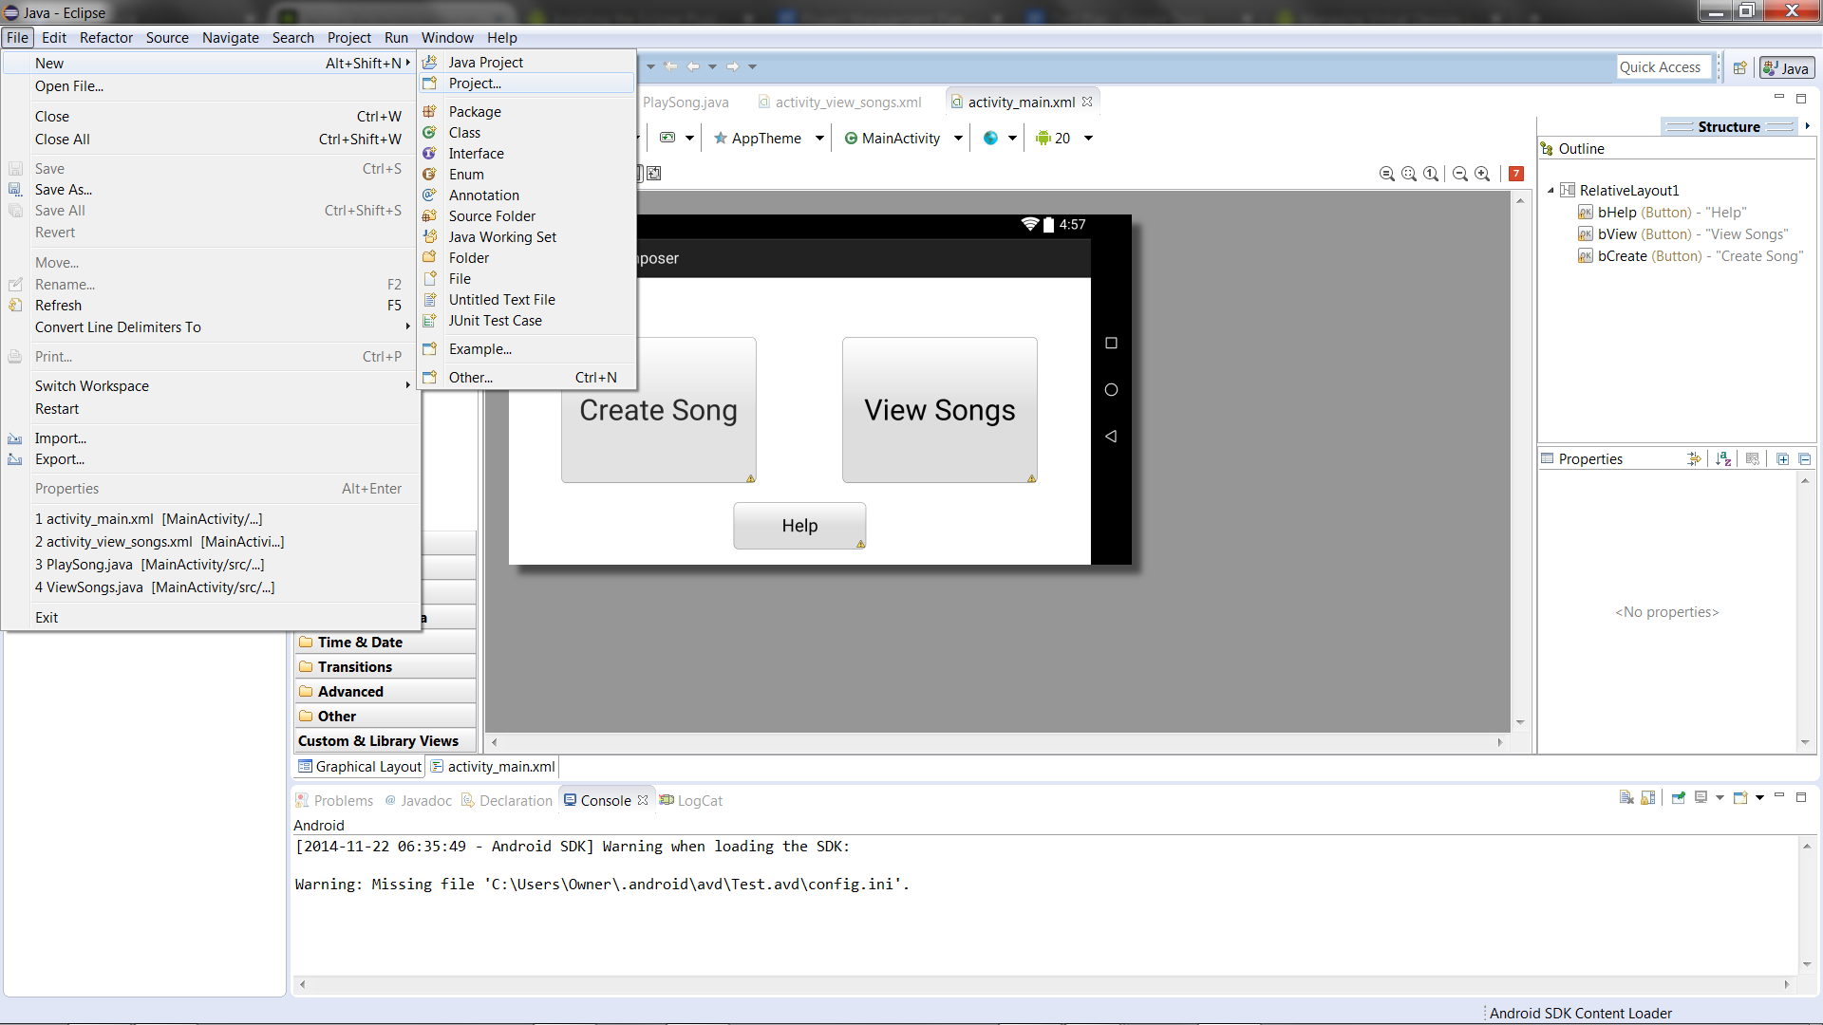

-Select “Android Project from Existing Code” in the window that opens

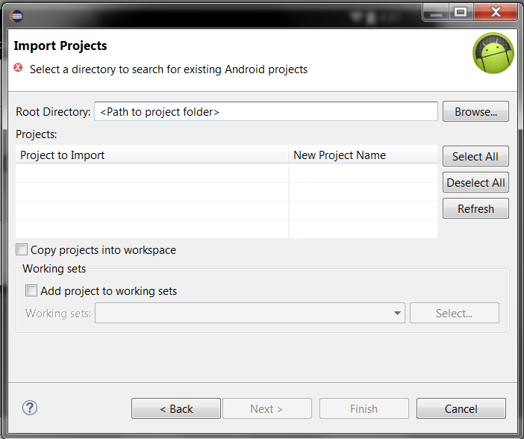

-Input the root directory of the Pocket Composer folder and checkmark the box if you wish to copy the code into your workspace. Hit finish to move it in.

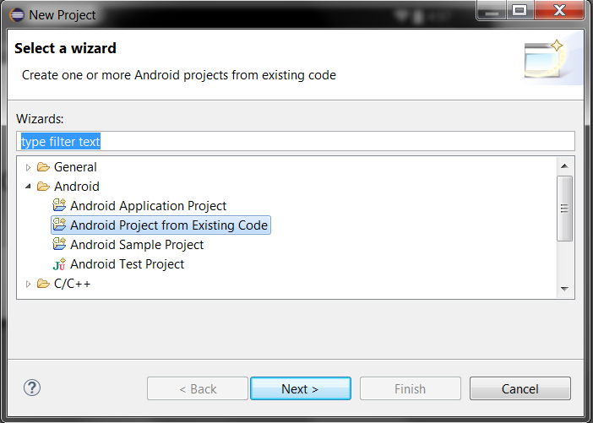

-Now the project should appear in your Eclipse Package Explorer on the right hand side.

In order to run on an Android device:

-Plug in your Android device into a USB port

-Your Android device must have its developer settings on. The method to activate these settings differs per device, so please consult the device manual or internet if you are unsure how to access them.

-Go to the toolbar and select Run\Run Configurations as shown below

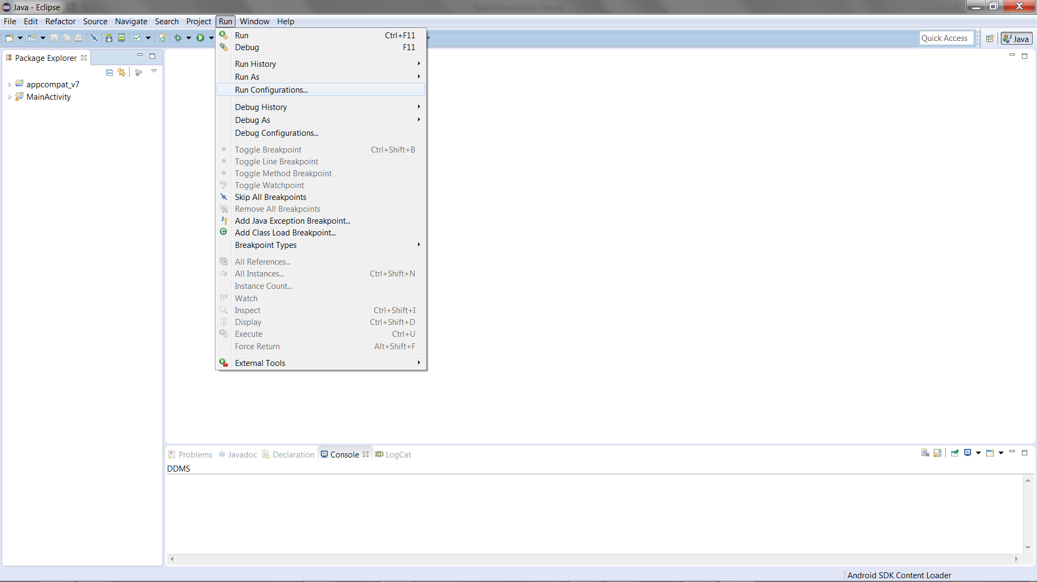

-Double click the Android Application option to create a new Run Configuration, and browse for the main project folder.

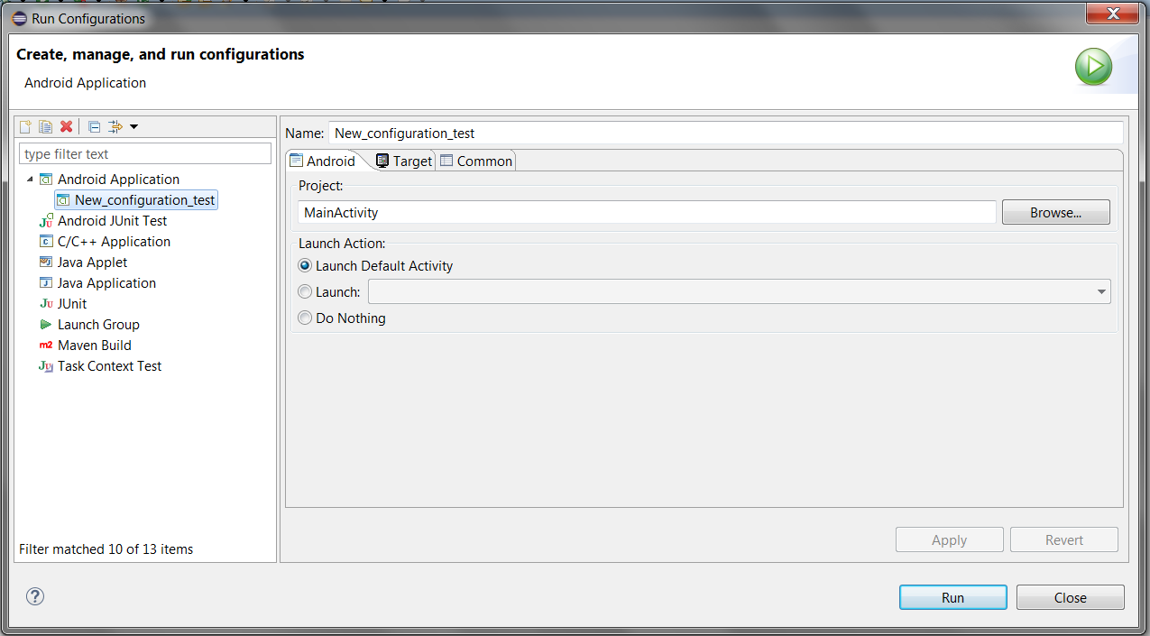

-Under the Target tab it is also helpful to hit the “Always prompt to pick device” checkbox to better control where the application will run.

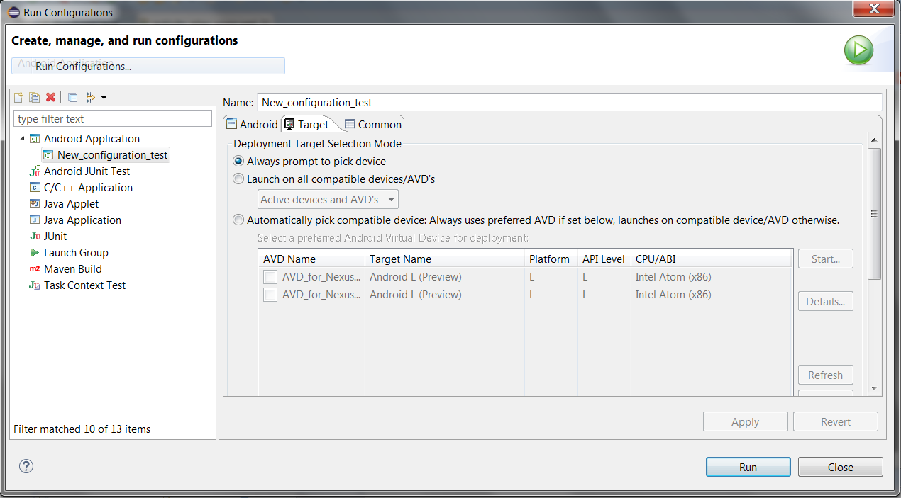

-Afterwards hitting run should display this screen where your selected Android device will show up in devices if properly connected.

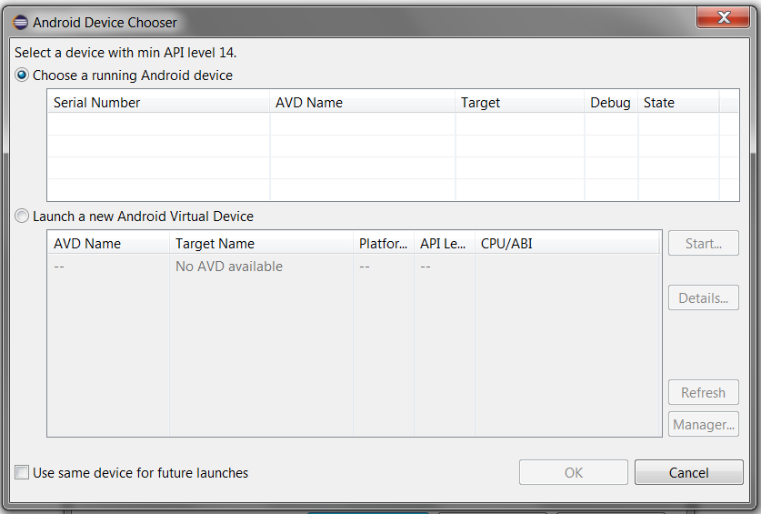

-Select your device, make it is unlocked, then hit okay to begin loading the application to your phone.

-Once it has loaded the application will automatically open on your screen!

How to run on an Android Virtual Device (AVD):

-In order to run, an AVD must be created. Be sure that you have the Intel x86 Emulator Accelerator (HAXM) installed.

-This can be done by opening the Android SDK Manager

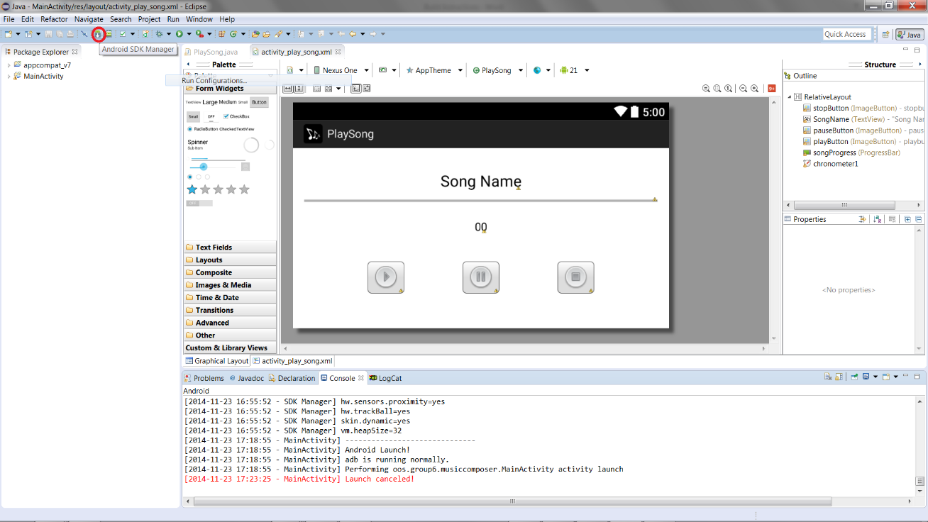

-And then installing the correct package:

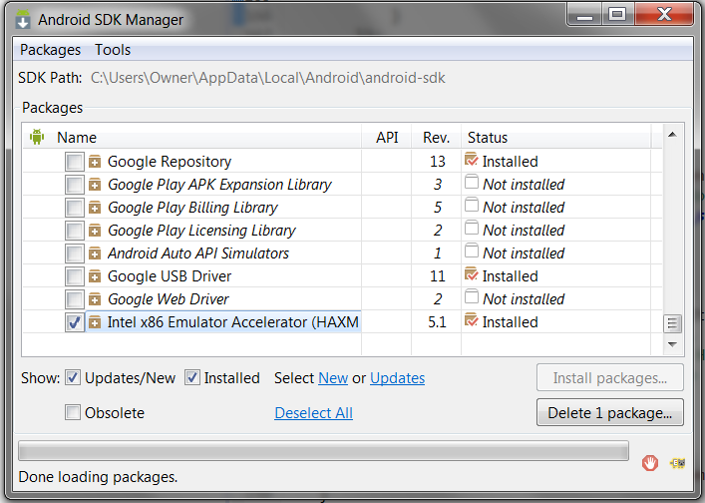

-Once installed, navigate to the following directory and run the .exe to complete installation

**{SDK_FOLDER}\extras\intel\Hardware_Accelerated_Execution_Manager\intelhaxm.exe**

-Now to create an AVD, click the AVD button on the toolbar:

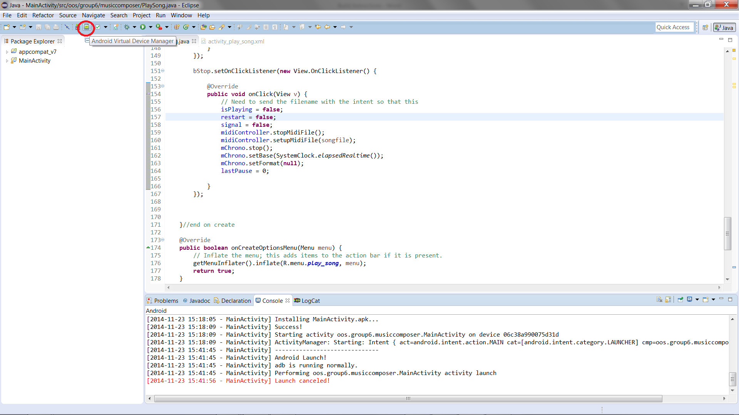

-In the AVD Manager, click on the device definition tab and select the device you would like to run on. For our purposes, the Nexus One was used. Select it from the list and hit the create AVD button:

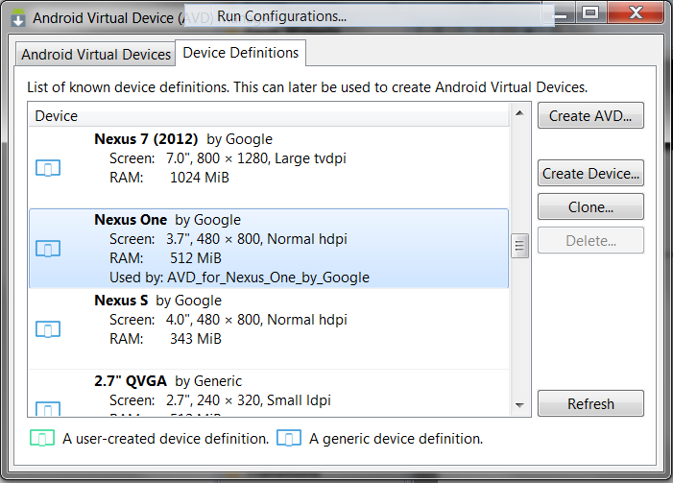

-The following are the settings used to set up our AVD

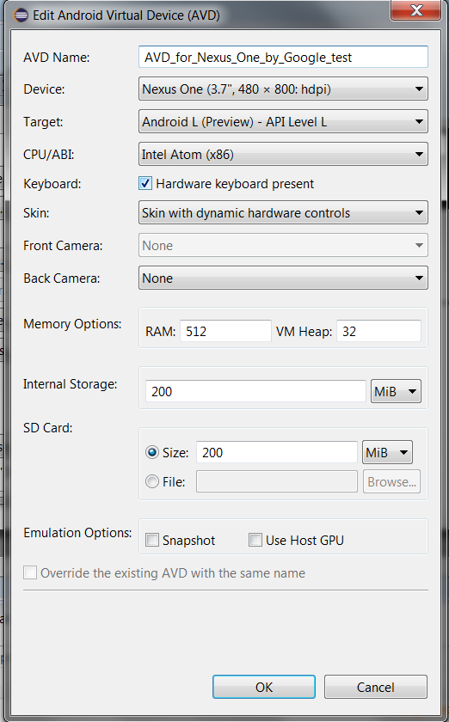

-Clicking “OK” will save the device, and it should appear in the AVD Manager.

-Now to run, go to the toolbar and select Run\Run Configurations as shown below



-Double click the Android Application option to create a new Run Configuration, and browse for the main project folder.



-Under the Target tab it is also helpful to hit the “Always prompt to pick device” checkbox to better control where the application will run.



-Afterwards hitting run should display this screen where your created AVD should appear

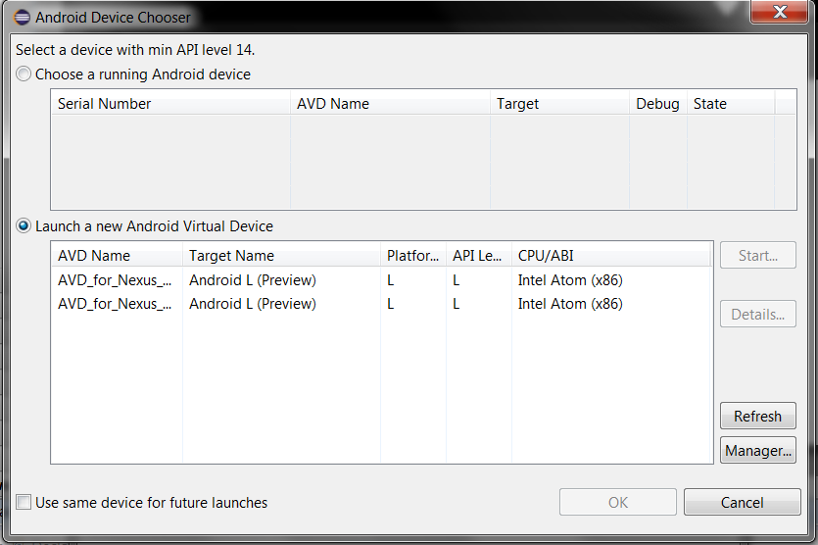

-Select you AVD and click “OK” to begin running! The emulator will open and run the application.